1. JDK (Download + Setup): -
   1. Download JDK from the official website i.e.,

<https://www.oracle.com/java/technologies/javase-jdk16-downloads.html>

* 1. Run the downloaded setup & press “Next” as prompted in following picture:

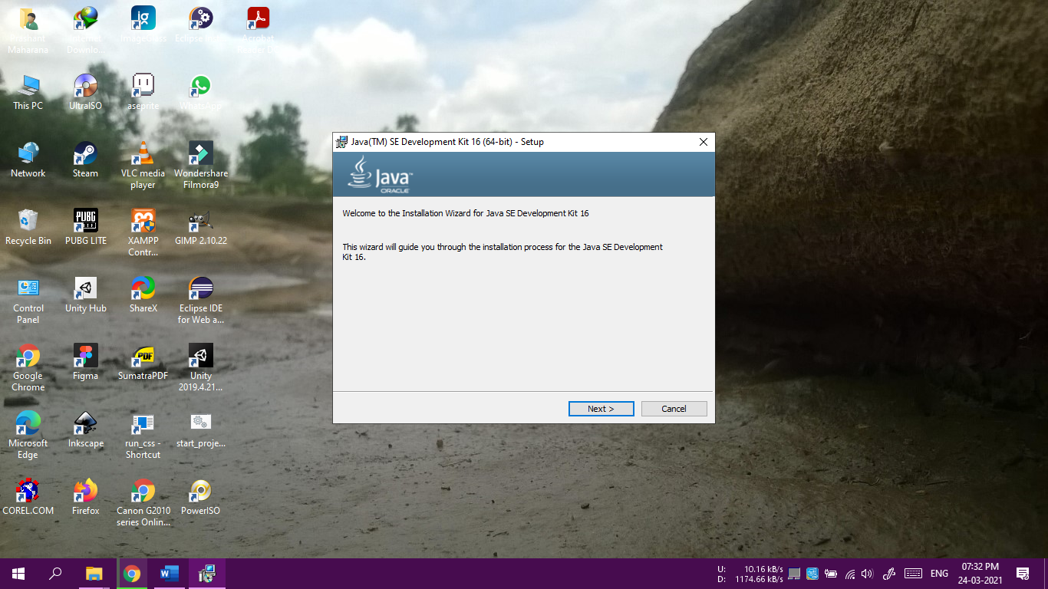

c. Press “Next” again as prompted in following picture:

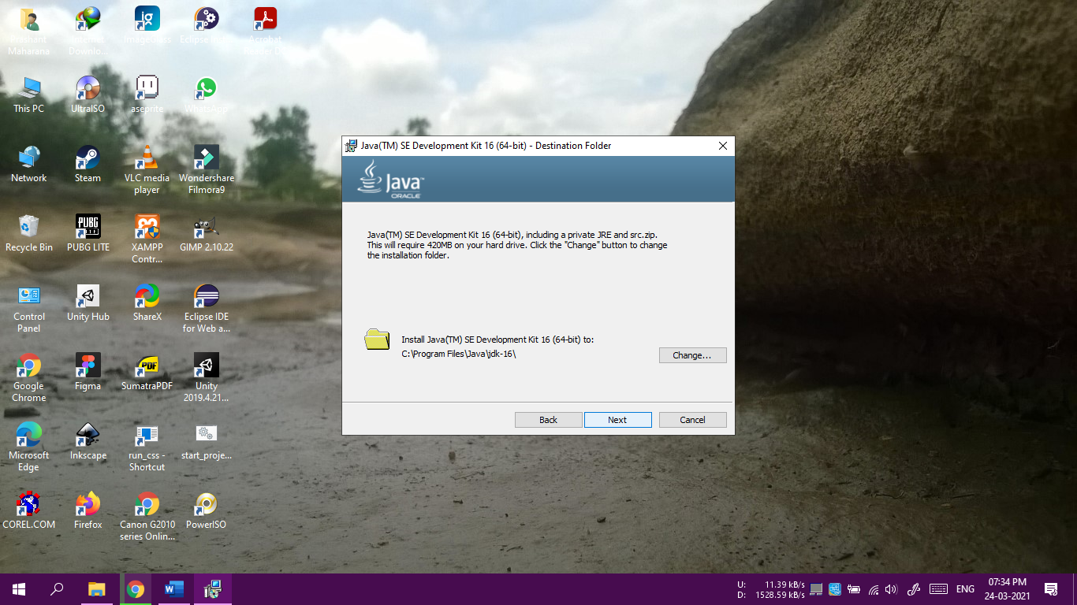

d. Wait till the installation process completes:

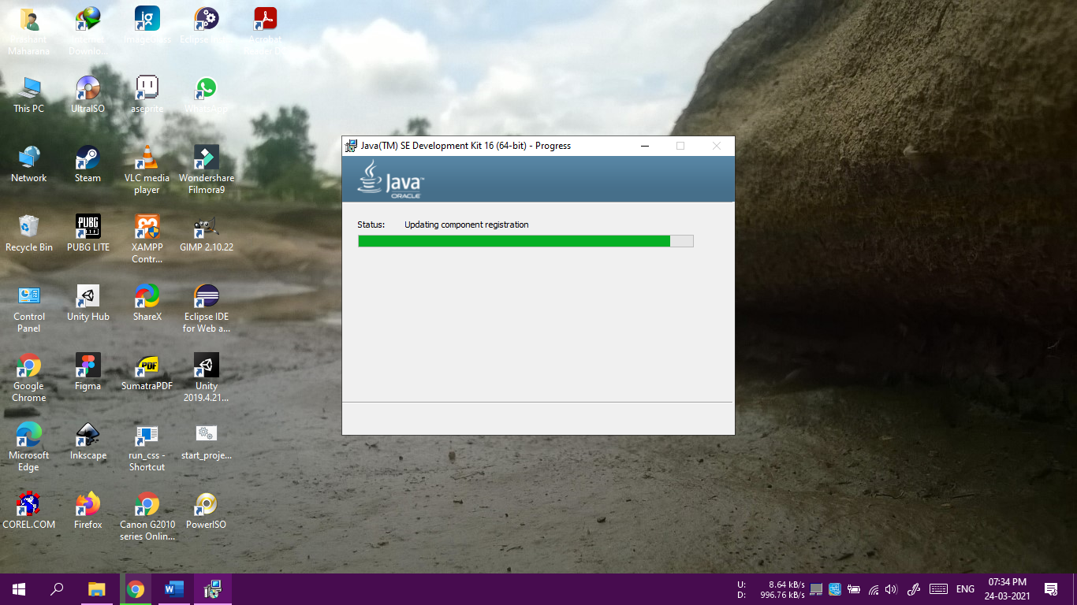

e. After the installation is completed, press the “Close” button to close the installer:

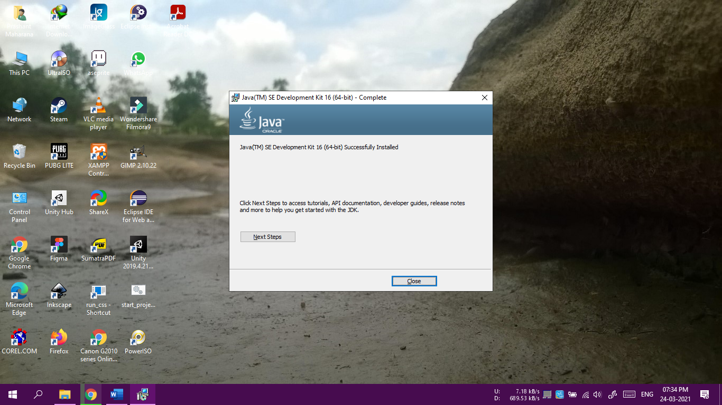

f. Now, comes the process of setting up the environment variable, for which right-click “This PC” shortcut available in your desktop/laptop, similar to following picture:

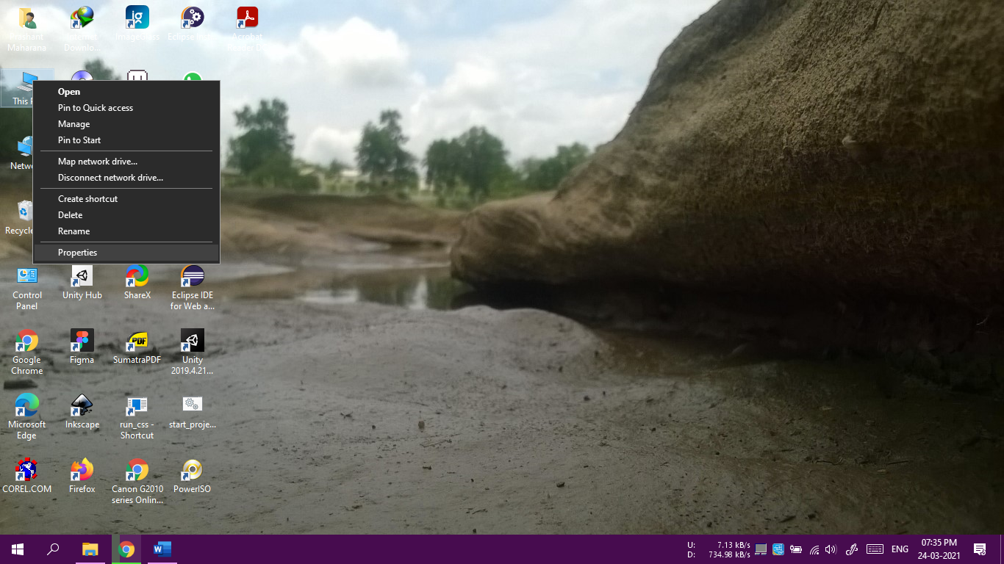

g. Locate “Advanced System Setting” option in the left menu items available in the current window, similar to following picture:

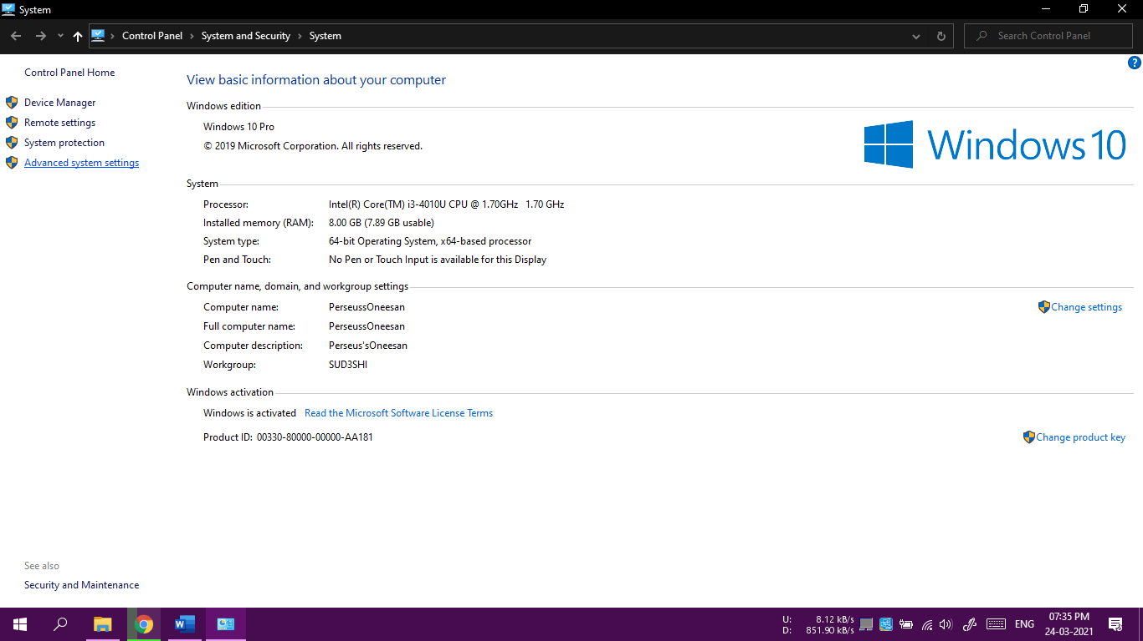

h. Locate “Environment Variables” button in the System Properties Window, similar to following picture:

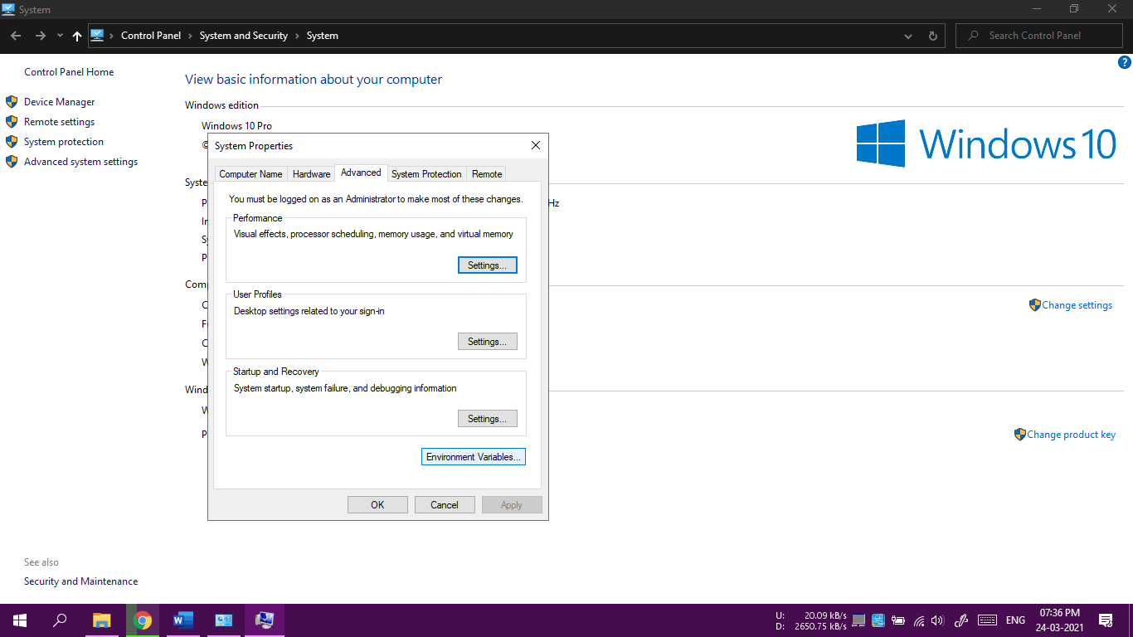

i. Click on “Path” in the “System Variables” Section of the window, and press “Edit” button, which is located just below the “System Variables” Section of the window similar to following picture:

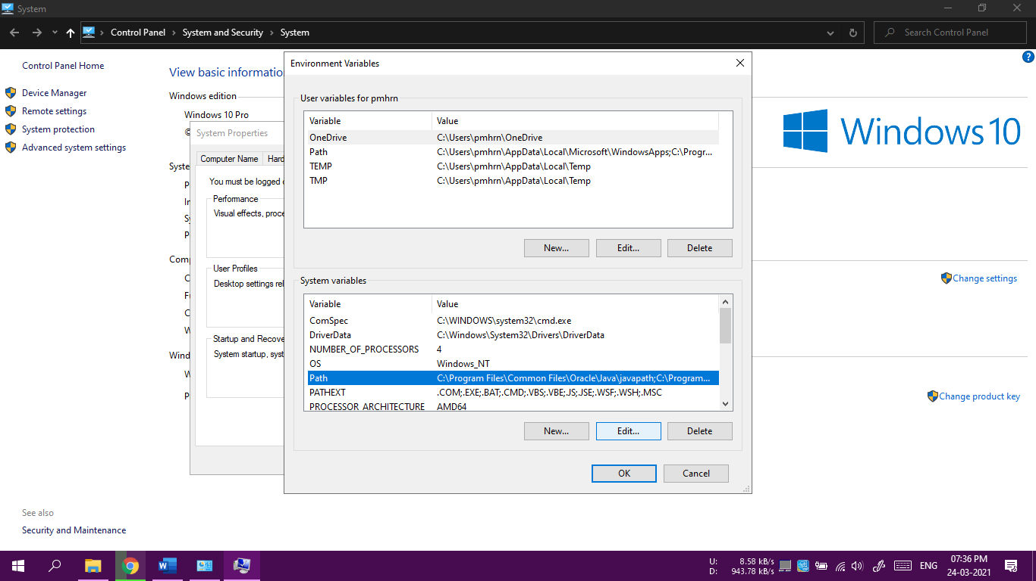

j. Press “New” button on the side and paste the text “C:\Program Files\Java\jdk-16\bin” (or you can navigate to the installation folder in case, default location wasn’t selected),

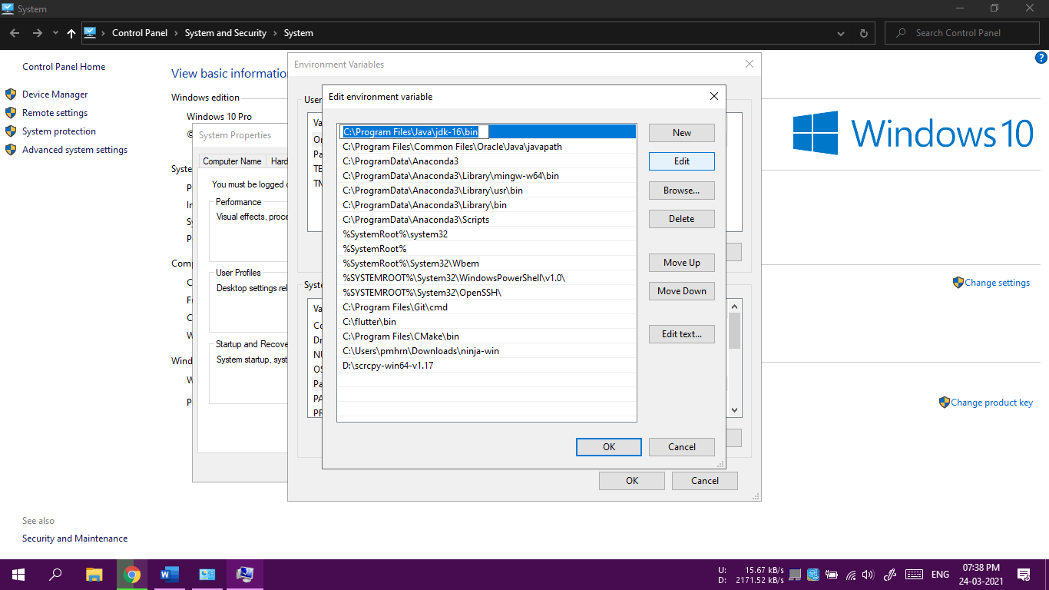

k. For verification of the installation and environment variable’s setup, Search “cmd” in windows search, and type “java -version”, which will generate output similar to following:

